**Classroom Activity: Passing an Object as a Prop**

In this example, the parent component passes an object as a prop to the child component. The child component uses the object to display information on the screen.

**Code:**

File Name: src/App.js

import React from 'react';

// Parent component

function App() {

    const user = {

      name: "Alex John",

      email: "alexjohn@edunet.com",

    };

    return <Note user={user} />;

  }

  // Child component

  function Note(props) {

    return (

      <div>

        <p>Name: {props.user.name}</p>

        <p>Email: {props.user.email}</p>

      </div>

    );

  }

export default App;

**OUTPUT:**

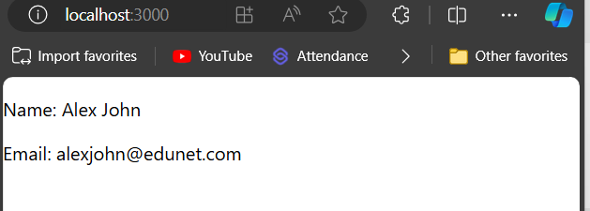

Figure: Output Screenshot

**Execution Steps:**

* Write the above code
* Go to VS Code terminal
* Execute following command to run the program: npm start
* This will open your default browser and navigate to http://localhost:3000, where you will see your new React application running.